EM304 – Integrated Design Project
Systems Engineering: Purpose Worksheet

In Lecture 1 we talked about how engineering was about using science and mathematics as tools to accomplish a purpose. We talked about how having a common understanding of that purpose is a vital part of a successful project team.
Discussing purpose using the following framing will help your group to build that common understanding. The list of terms in each row header should serve as prompts for your discussion.
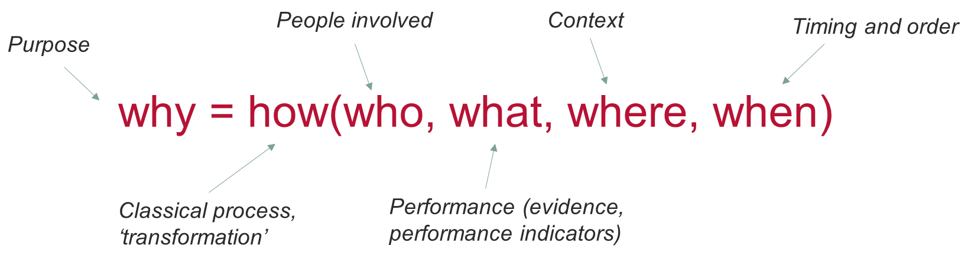
Use the table below to record your initial discussion about your group’s purpose. Use bullet points or a short paragraph to list the key points. Return to the lists as your project develops to reflect on how your collective understand has changed.

Key word: WHY

Have a conversation around:
- Purpose - Needs, Targets, Vision/ mission, Success/ failure, Problem/ issue
Charge car
Successful if can track car and connect to a certain point
Tracking function
Movement to desired location
Precision of final movement

Key word: HOW

Have a conversation around:
- Transformation: Physical behaviour, Models
- Decision: Alternative solutions, Evaluation criteria, Choice
- Resource: Money, Power, People, Equipment
Largely 3d printed if strength suffices – pretty cheap, should fit in budget

Key word: WHO

Have a conversation around:
- Roles: Owner, Client/ customer, Stakeholder, Functions, Players/ actors
Client is someone with an EV(Uni is the ev owner for the purposes of this project)
Uni also owner
We’re designers
All listed individuals are stakeholder, we care about grades, uni cares that we can design a good thing

Key word: WHAT

Have a conversation around:
- Form: Material/ structure, Connectivity, Hierarchy, Robustness, Language
- State: Variables, Parameters, Performance indicators
- Controls: Evidence, Planning, Prediction, Imagination, Scenarios, Opportunities
Scaled down model of gantry for ev charging
Made of PETG
Stepper motors for movement(possible gear reduction)
Camera to find in 3d space
Location found from constructed view(Michael found an api) no
Coded on ardiuno(language based on c)
Rails in x y and z direction with tracks on for movement
1:24? scale of space 125x250x100mm provisionally(for 3x6x2.4 m standard garage)

Key word: WHERE

Have a conversation around:
- Place: Site, Location
- Assumptions: Context, Super-system
Tabletop testing for scale model of garage

Key word: WHEN

Have a conversation around:
- Time: Start, Finish, Critical path, Slack
System definitions, scale, CAD model, and electrical systems by end of sem 1
Main structure printed sem 2 wk 3
First test sem 2 wk 5
Imrovements rest of sem 2

